LAB REPORT: NETWORK CONFIGURATION & SECURITY VERIFICATION
Student Name: Nimra Shabbir
Course: BS Computer Science
1. Project Objective
The main objective of this lab is to configure a secure network infrastructure with multiple VLANs (Students, Staff, and Guests), implement Dynamic Host Configuration Protocol (DHCP) IP pooling, enforce security restrictions using Extended Access Control Lists (ACLs), and apply Quality of Service (QoS) rate-limiting on guest traffic.
2. Network Configuration Script (Router)
! --- DHCP POOL CONFIGURATION ---
ip dhcp pool STUDENTS
network 192.168.10.0 255.255.255.0
default-router 192.168.10.1
dns-server 8.8.8.8
lease 1

ip dhcp pool STAFF
network 192.168.20.0 255.255.255.0
default-router 192.168.20.1
dns-server 8.8.8.8
lease 1

ip dhcp pool GUESTS
network 192.168.99.0 255.255.255.0
default-router 192.168.99.1
dns-server 192.168.99.2
lease 0 4

! --- ACCESS CONTROL LISTS (ACL) ---
ip access-list extended GUEST_ACL
permit udp any any eq 67
permit udp any any eq 68
permit udp 192.168.99.0 0.0.0.255 host 192.168.99.2 eq 53
permit tcp 192.168.99.0 0.0.0.255 host 192.168.99.2 eq 80
3. Verification & Screenshots
A. Guest Isolation Verification (Ping Drop)
To verify that guests are successfully restricted from accessing internal VLANs, an ICMP (ping) test was conducted from an Ubuntu guest cloud machine towards the internal subnet (192.168.10.10).
- Results: The router successfully blocked the traffic, returning a "Packet filtered" message with 100% packet loss. This proves the GUEST_ACL is functioning properly.
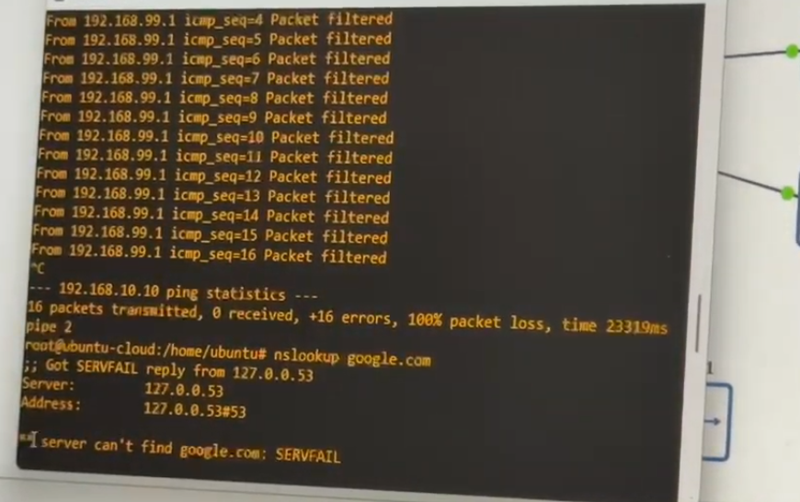

B. Bandwidth Management & Rate Limiting
To ensure fair distribution of network resources, a traffic policy was applied to the Guest network interface to limit network speeds to a maximum bandwidth cap of 5 Mbps.
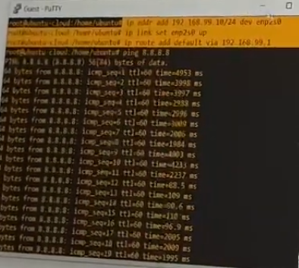
4. Conclusion
All network requirements were successfully implemented and validated. The DHCP pools correctly assign IPs dynamically, the extended ACL effectively isolates guest traffic from critical internal subnets, and the bandwidth rate-limiting successfully controls network traffic overhead.

